
Submitted by : Spogmai Jan
Roll no : 2430 -0081
Submitted to : sir nouman asim

Computer networks lab 11

TASK 01:
Design a Network which Divide a Class C network into multiple subnets. Calculate subnet
addresses, subnet masks, usable IP ranges, and broadcast addresses for each subnet. Understand
the effect of subnetting on IP allocation and network structure.
By using 2 routers and 2 switches, DHCP server connect with Router0. Divide the network
(subnetting) as given below Subnet hosts connect on 2switches with Router1. Router1 connect
with Router0 to get the IP address from DHCP server, you are given the IP address
192.168.10.0/24. Your task is to create subnets that meet the following requirements:
1. Subnet 1: Should support 50 hosts.
2. Subnet 2: Should support 30 hosts.

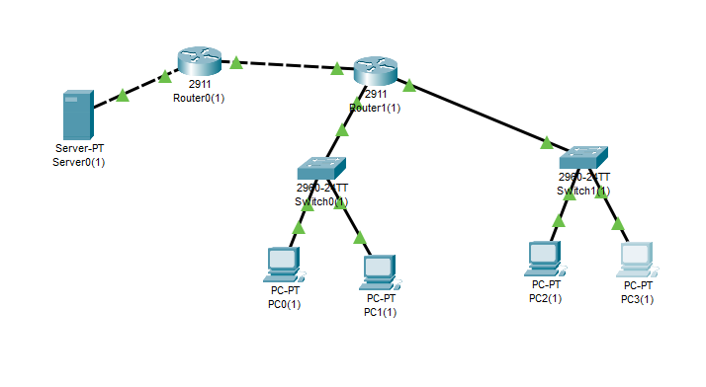

SUBNET 1 IPS:
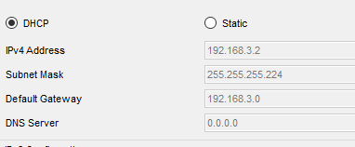
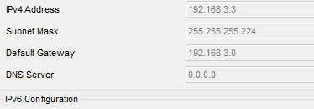
SUBNET 2 IPS:

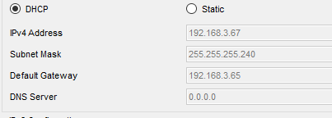
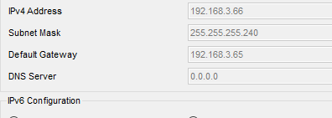

TASK 2:
192.168.2.0/24.

Subnet 1: Should support 60 hosts.
Subnet 2: Should support 15 hosts.
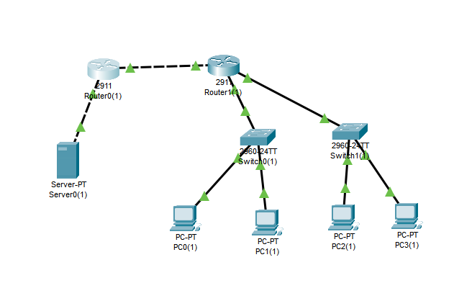
TASK 03:
SUBNET 1:
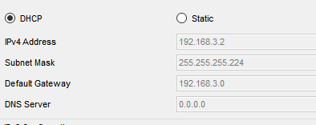

SUBNET 2:



